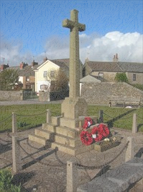
Local Government Act 1972
Notice is hereby given that the
Annual Parish Meeting
will be held at
The Swarthmoor Reading Rooms on Monday 11th May 2025 at 7:00pm
Helen Slater – Chair - person Pennington Parish Council

Agenda
The Annual Parish Meeting is a platform whereby the Parish Council can explain and summarise its business over the last year and allows electors to have their say on anything they consider to be of importance to people of the Parish.
The Annual Parish Meeting is a meeting of the electors and NOT of the Parish Council. Anyone may attend but only electors of Pennington Parish may vote on anything raised within the meeting.

Minutes of the last Meeting – 12.05.2025

Chairman’s Annual Report

Community Group Reports

Public Participation

